The Second World War 1939-1945 Answer Key
Chapter 8

World War Two and the Great Depression (Smartboard notes)

- During the years in between the two World Wars, there was an
event called The Great Depression
- This was an economic event that caused many people to be out of
work/jobs/employment and not have enough money for basic needs.

- What did this cause?

These events caused tensions because people's needs were not being met and this caused people to look for other ways to organize their society.

- The people turned away from democratic leaders as governments who seemed to be unable to stop the economic downturn and help people meet their basic needs. They turned to parties such as the Nazi Party.

- Countries like Germany, Italy and Japan were taken over by aggressive leaders who saw war as a solution to their problems.

- Complete the table listing the names of countries (189):

Allies | Axis (Allies enemies)
Britain  Canada  Newfoundland  Austrailia  U.S.  Russia  France | Germany  Italy  Japan

- What major event started the Second World War? When did this happen? (189)

When Hitler invaded Poland September 1st, 1939.

- Explain the expression « theaters of war» (189)

Key geographical areas where major battles took place

- What type of military action occurred in WW2? Was it all land? (hint look at the map legend on page 188)

It was a more mobile war that happened on land, sea, and air. There was fighting in Europe in WW2 as well as in Asia, Africa, and Australia. In addition to the war in the Atlantic Ocean, there were naval battles in the Pacific Ocean, Indian Ocean, and Mediterranean

- What did the letters in « NFLD » stand for ? (189 –FYI)

No found lying down

- Where did the Newfoundland Regiment serve in WW2 and why ? What was their job (189)

In World War Two the British government encouraged Newfoundlanders and Labradorians to join branches of the ?British military rather than fund the Regiment overseas. In WW2, the Regiment served at home to defend Newfoundland.

- Who are these people ?

Winston Churchill (191) Winston Churchill: head of the British Navy. Britain's PM 1940-1945

b) Adolf Hitler (189)
Adolf Hitler: leader of the Nazi party. Leader of Germany 1939 to 1945

- Name the 3 Newfoundland Units in the British forces (189 :
a) the 166th Field Regiment, (army)
b) the 59th Heavy Regiment (army)
c) the 125th Squadron (Royal Air Force)

- Together you will fill out this concept map of mens and women’s enlistment based on the chart and readings on page 190. Note the enlistment numbers.

- Men’s Enlistment
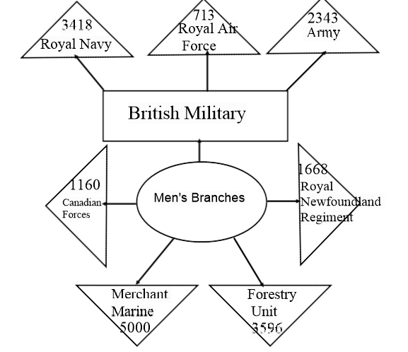

- Women’s Enlistment

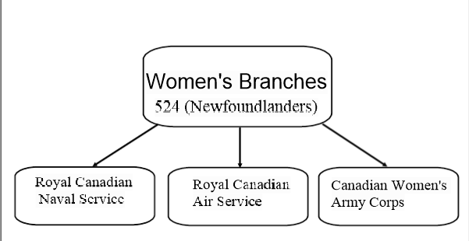

Newfoundland Troops Overseas: (192)

- Where did Newfoundlanders serve on sea, land and air?

On sea: hundreds of ships on the Atlantic, Indian and Pacific Oceans.
On land: defensive duty in the UK and other battlefields such as Asia and Africa.
In air: fought in the skies over Europe, North Africa, the Middle East, and the Far east.

- Define: Prisoner of War (192)

Internee: a person held in an internment camp during the war. Prisoner of War: members of the enemy forces who were captured in an area of conflict.

- Read the letter on page 194. Who is the letter writer?

Joseph Kearney

- Why do you think the letter examined by a censor (hint it was wartime)?

So the writer would not give away any information abou the location of where they were being held or their treatment as a POW.

The War at Home: (195)

Volunteers:

- The Women’s Patriotic Association was active during WWII. What added responsibilities did they have from their roles in WW1?

The Women’s Patriotic Society (WPA) reassembled for WWII and their duties were similar to WWI, they worked 6 days a week to supply the troops with knit hats, surgical materials & more care to the troops locally

Page 196:

- The Newfoundland Patriotic Association (NPA) raised funds for the war with 2 new fundraisers. What were they called:

- One Percent Scheme
- Fish a Man Fund

- What was the One Percent Scheme? The Fish a Man Fund?

a) One Percent Scheme- a voluntary donation of one percent of a salaried person’s pay before taxes
b) Fish-a-Man Fund- one fish from each fisherman each season

