Visual Portion of the Heritage Fair
VJH 2016

In this section of the Heritage Fair, students are required to prepare both an oral and visual presentation of their research. Your backboard or the PowerPoint is to follow the order of the research outline you passed in. The purpose of your project is to present to viewers an oral and pictorial summary of your topic. Presentations must be between 5 and 10 minutes.
Backboard Display
For students who choose a backboard display project consider the following:
- Use a balance of text and pictures to tell the story of your project! Don’t have all text or all pictures on your backboard.
- Do not include paragraphs and paragraphs of text. The text portion is meant to be a summary of each heading.
- Include such things as artifacts, photos, illustrations and newspaper/magazine clippings as these are part of your mark as are props and/or costumes.
- Creativity and organization are also part of the mark for your backboard display in addition to content.
- Use a text and font that is easily visible (22-24 size font suggested)
- Including your full name(s) and teacher on the backboard.
- See example below
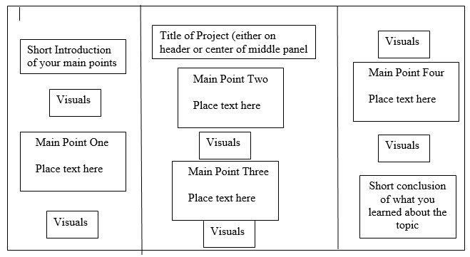
PowerPoint Display
For students who choose a backboard display project consider the following:
- Your Powerpoint should be a balance of text and pictures.
- Slides should not be blocked with paragraphs of text. Each slide is meant to be a summary of your information for each section
- Each slide should have text and pictures or alternating text/picture slides.
- Use a background, colour and font that are easily seen by the audience. Test your background out on a family member or friend to see if they can read it.
- Font size no less than 24.
- Slide one should be a title slide with your topic, name, and homeroom.
- Slide two should be an introduction to your topic (your 4 or 5 main points)
- The last slide should be a conclusion of what you learned about your topic
- Should have 2 slides for each main point. So a project with 4 four main points should have a minimum of 10 slides and a project of 5 main points should have 12 slides (these include your intro and conclusion)
- Include such things as artifacts, photos, illustrations and newspaper/magazine clippings as these are part of your mark as are props and/or costumes.
- Creativity and organization are also part of the mark for your PowerPoint in addition to the content.

