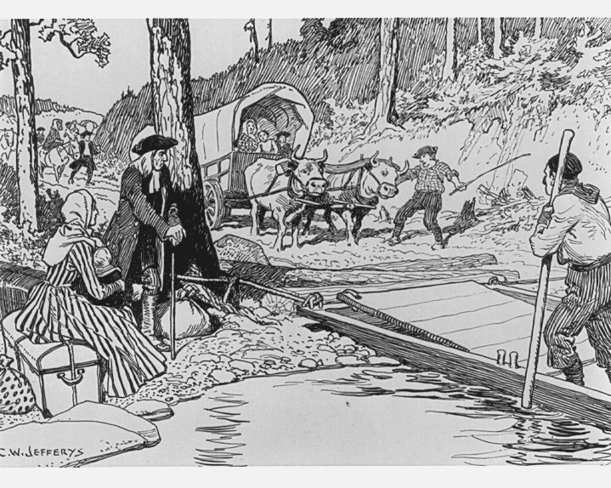

Social Studies Grade 7
2016

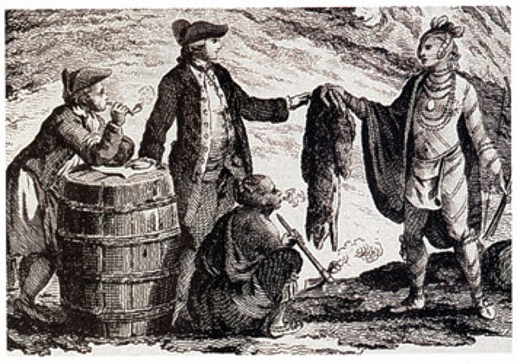

The People of
British North America

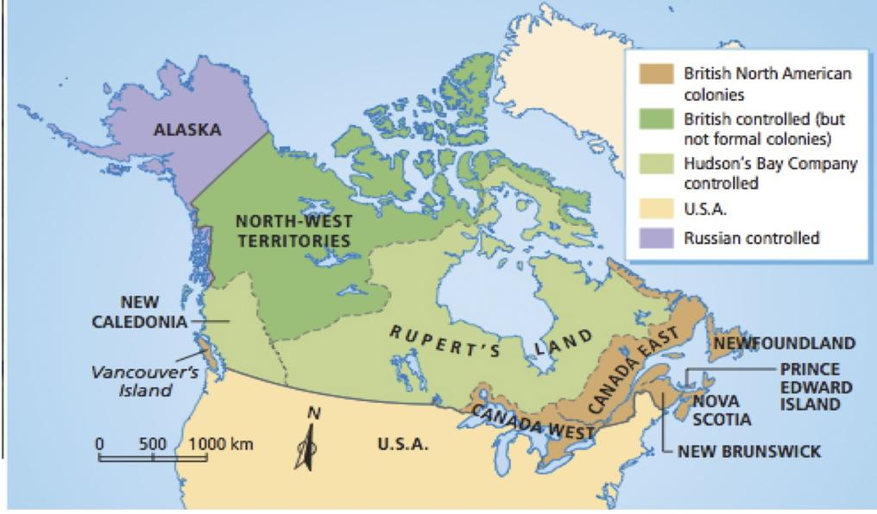
Name and Homeroom:

____________________________

Section One: The British and Irish

Read it! : Read pages 82 and 83 and then fill in the blanks

The Peoples of British North America (p. 82)
- An __________________ is a person who comes to live in a country that is not his or her original home. (see the box at the side of the page)

- In the early 1700s and 1800s, most of the immigrants came from __________________

The British and Irish (p.83)
- Between 1815 and 1850, about __________________ immigrants came to BNA from England, Scotland and Ireland.

- They came to BNA hoping for a __________________

- Many of the English were __________________ against the Irish.

- There were problems between the people of __________________ and in __________________

- The Irish tended to be __________________ while the English tended to be __________________ (religions).

The British and Irish (p. 82)
- By the mid-1800s, approximately ______ of the European population of BNA was British or Irish.

- A class of people who have more political, economic and social power are called the _______________.

- The __________________ came to Canada after the American Revolution.

- In Newfoundland, the British ________________ also formed an elite.

- The elite in all the colonies had:
- most say in __________________
- owned the __________________
- set the social __________________

- The elite weren’t interested in sharing their __________________ with others.

Define It! Write down the definitions for: (look in the box on the side of the page)

Prejudice:
____________________________________________________________________________________ __________________________________________________________________________________________________________________________________________________________________________

Discrimination: ____________________________________________________________________________________ __________________________________________________________________________________________________________________________________________________________________________

Section Two: The French

Read it! Read page 84 and fill in the blanks in the textbox
The French (p.84-85)

- The two main groups were in __________________ and the __________________ in Atlantic Canada.
- In Newfoundland, they lived along the ________________________
- When Great Britain took over BNA, they gave the French the rights to keep:
_______________________________ _______________________________
_______________________________ _______________________________
- As more British and Irish moved into Canada East, the French feared they would become and ____________________ and lose their rights.
- Define: Habitants_____________________________________________________________

Investigate It! Read page 85 and find out the who, what, when, where and why of the Grand Derangement

Who?? ______________________________________________________________________________

What?? _______________________________________________________________________________________________________________________________________________________________________________________________________________________________________________________________
_____________________________________________________________________________________

Where??
__________________________________________________________________________________________________________________________________________________________________________

When?? __________________________________________________________________________________________________________________________________________________________________________
Why?? _______________________________________________________________________________________________________________________________________________________________________________________________________________________________________________________________

Activity: Sketch it!
In the space below, draw a picture of what you think it might have looked like when the British came in to burn down their homes or as the Acadians were leaving their homes to find a new place to live

Activity! There are Three Sides to Every Story!

In this activity you will be placed into groups and will be assigned to be either British or Acadian. Using materials given to you by the teacher, you will find out how your “side” felt about the Grand Derangement and each group will present their views to the class. You will be provided with a chart paper and a marker. You will all contribute to what points you should write down. A recorder and reader should also be designated.

Section Three: The Aboriginal Peoples

Define it! Read page 86 and 87 and find the following definitions
Racism: _________________________________________________________________________
________________________________________________________________________________
Resistance (to disease): _____________________________________________________________
_________________________________________________________________________________
Tuberculosis: ______________________________________________________________________
_________________________________________________________________________________
Wampum: ________________________________________________________________________
_________________________________________________________________________________

Fill It! Read pages 86 and 87 and fill in the blank
Aboriginal Peoples (p. 86-87)
- The arrival of the Loyalists, British and Irish in the Maritimes created a demand for ________________
- In Nova Scotia, PEI and New Brunswick, the First Nations people were left with ______________________________________________________
- The population of First Nations and Inuit dropped to about __________________ in 1871.
- The drop in population was mostly due to __________________
- By the mi-1800s, the largest Métis community was in _________________________________
- The Red River Settlement was in the region controlled by ______________________________
- Most Métis were involved in the __________________
- They transported goods by __________________, __________________, or _______________
- Why were Métis carts designed so their wheels could be taken off? __________________ ________________________________________________________________________

Design it! Design your own wampum in the box provided. What message would it give the Europeans?

Section Four: The Black Colonists

Fill it! Read pages 88 and 89 and fill in the blanks!
Black Colonists (p.88-89)
- Slavery was legal in BNA until ____________________
- Some Black people came from ____________________, but most came from the ____________________
- Approximately ______________ Black Loyalists came to BNA and settled in ____________________________________________________________
- They set up strong communities to provide: ____________________, _________________ and ____________________ for their people.
- Black people came to BNA between 1840 and 1860 to escape ________________________________________________________________________
- As white communities grew larger, Black colonists were forced to move farther from ____________________ such as ____________________ and __________________
- What job is the Black Loyalist doing in the image on page 88? ________________________________________________________________________

Define It! Give Definitions of these terms:
Title ________________________________________________________________________________
____________________________________________________________________________________
Slavery: _____________________________________________________________________________ ____________________________________________________________________________________

Journal it! Which group do you feel suffered the greatest hardship and why? Or did they all face hardship but in different ways. Write your thoughts and feelings in the box below. Make sure to support your answer using information from the text and use a topic and concluding sentence.

________________________________________________________________________________________________________________________________________________________________________________________________________________________________________________________________________________________________________________________________________
________________________________________________________________________________________________________________________________________________________________________________________________________________________________________________________________________________________________________________________________________
________________________________________________________________________________________________________________________________________________________________________________________________________________________________________________________________________________________________________________________________________
________________________________________________________________________________________________________________________________________________________________________________________________________________________________________________________________________________________________________________________________________

Booklet Check:
Is every question completed?
Is your name and homeroom on the front of the booklet?
Are you with happy about how you worked on this booklet?
Give yourself a pat on the back. You are now finished your booklet

