Sources of Information
Booklet
Name:_____________________
Class:_______________
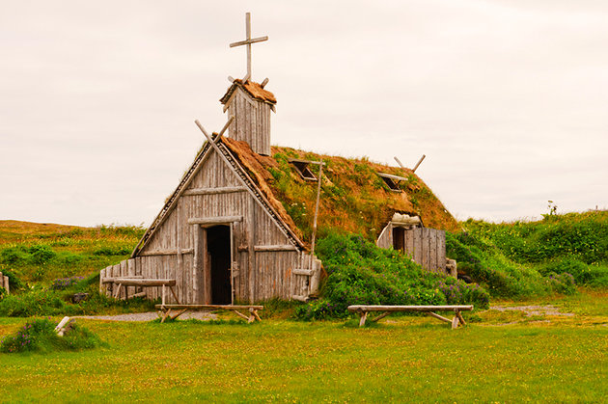
Grade 8 Socials

Sources of information  - Libraries and Museums:  ______________________________________________________________  ______________________________________________________________  ______________________________________________________________  ______________________________________________________________  ______________________________________________________________  ______________________________________________________________  - Archives:  ______________________________________________________________  ______________________________________________________________  ______________________________________________________________  ______________________________________________________________  ______________________________________________________________  - Monuments:  ______________________________________________________________  ______________________________________________________________  ______________________________________________________________  ______________________________________________________________  - Historic Sites:  ______________________________________________________________  ______________________________________________________________  ______________________________________________________________  ______________________________________________________________ |  |  | - Internet:  ______________________________________________________________  ______________________________________________________________  ______________________________________________________________  ______________________________________________________________  ______________________________________________________________  ______________________________________________________________  - Oral History:  ______________________________________________________________  ______________________________________________________________  ______________________________________________________________  ______________________________________________________________  ______________________________________________________________  ______________________________________________________________  - Literary and Artistic Expressions:  ______________________________________________________________  ______________________________________________________________  ______________________________________________________________  ______________________________________________________________  ______________________________________________________________  ______________________________________________________________

