Of Men and Seals:
In Class Assignment
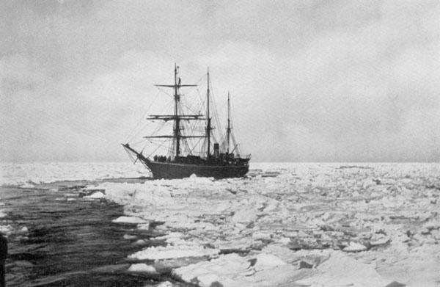

Read this description of freeing a vessel from the ice found in Wooden Walls Among the Ice Floes by Major Howe Greene. Then draw a picture or write a diary entry depicting /describing the freeing of a vessel from the ice floes during the seal hunt. You can create a fictional vessel or you may use one learned about in class.

Instantly the whole (steam) ships company wakes to life and action- there is no need to ask anyone what has happened. The sleepers come rushing up from below. Long poles are hauled out by some and thrown onto the ice to men already there. Others jump over the bulwarks armed with great ice chisels, each one of these a foot across the blade and fitted with heavy handles five feet long. There are men with cross handled saws of about the same length as the chisels; and all these men get to once to work cutting the ice all around the ship into sheets., while others with axes chop round the bow and sides among a shower of flying ice splinters. All know what to do and there will be no confusion, while everywhere round the ship will be seen the hefty crew with each man working his hardest, knowing how much it depends on it.

The captain now orders out a heavy hawser; and almost before his words are spoken one coil is following so quickly after the other that in a few tens of seconds the end of its some 200 feet ahead, so great is the impetus of racing men. Then half a hundred stalwart fishermen tail onto it as if for a mighty tug of war; pulling the bow down and striving to clear her by breaking down the ice that lies in front and to the sides of her, every man straining every nerve and muscle on the rope. A bomb is placed ahead and fired with hardly a warning cry- but with little visible effect, perhaps luckily for the heedless men.

On board a close packed crowd runs at the word of command from one side to the other, leaning far out over the bulwark. It seems a great game of “Tag” with their shouts of “Over-r-r-r” and “Back again”, as they strive by their weight to roll her clear. Like a lot of children they push and shove, and lean on each other as they reach the rails at the end of each rush; yet though they shout and laugh, all is in deadly earnest. For it is by this crowding of their weight together that they effect a greater rolling leverage on the hull.

As there is no move yet – the direction of haulage is reversed. Back to the stern the hawser goes from beyond the bow, and again comes the dragging of its heavy coils at an express speed. Then with some of the crew still rolling her, with others loosening the ice that has already been cut, pushing great pieces of it under the Floe with the risk of ducking unheeded- with engines reversed and boilers at their fullest power, the whole of the men left free will haul and drag on the hawser’s end – panting, sweating and pulling.

Hawser: A cable or rope used in mooring or towing a ship.
Bulwark: an extension of a ships sides above water level;

