Newfoundlanders and Labradorians in WW1

Write a brief bio of the following soldiers. You must include information about their life before the military as well as military accomplishments

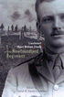
Owen Steele

__________________________________________________________________________________________________________________________________________________________________________________________________________________________________________________________________________________________________________________________________________________________________________________________________________________________________________________________________________________________________________

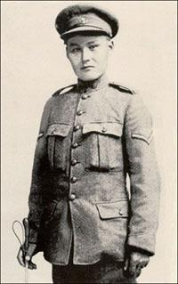_________________________________________________________________________________________________________________________________________________________________________________________________________________________________________________________________________________________________________________________________________________________________________________________________________________________________________________________________________________________________
John Shiwak

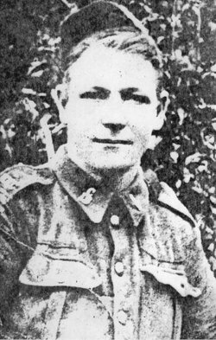________________________________________________________________________________________________________________________________________________________________________________________________________________________________________________________________________________________________________________________________________________________________________________________________________________________________________________________________________________________________
John Bernard Croke
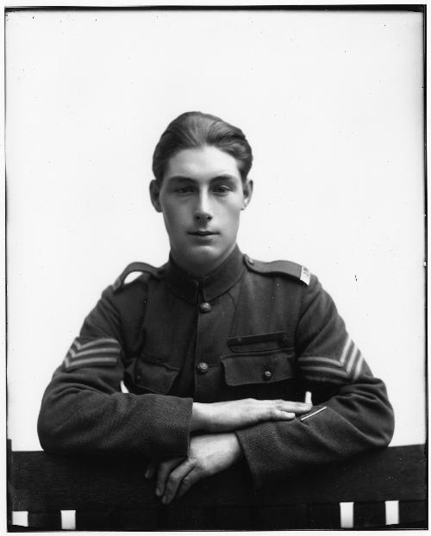
__________________________________________________________________________________________________________________________________________________________________________________________________________________________________________________________________________________________________________________________________________________________________________________________________________________________________________________________________________________________________________
Tommy Ricketts

