Newfoundlanders and Labradorians in WW1 Key

Write a brief bio of the following soldiers. You must include information about their life before the military as well as military accomplishments

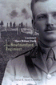
Owen Steele (1887-1916)

- Born in St. John’s April 28th
- Born into a wealthy family
- worked with his father in a crockery store
- He was well liked, intelligent, athletic and a volunteer.
- He was a member of the Newfoundland Highlanders – a military training organization.
- Enlisted in the Regiment Sept. 1914.
- He was a member of the Blue Puttees(#326)
- Promoted to corporal, then to sergeant and finally to lieutenant within a short period of time.
- He died as a result of injuries sustained when a German shell exploded next to him .
- He passed away July 8th, 1916.
- He kept a diary of his war experiences that gave great insight into what war is like for soldiers.

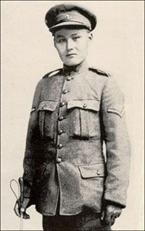
John Shiwak
(1889-1917)

- Born in Rigolet Labrador 1889
- He spent his life trapping, drawing and writing.
- He developed excellent hunting and shooting skills.
- Shiwak enlisted July 1st, 1915 and got to “The Front” July 1916.
- He became known as the best sniper in the British Army.
- He became a corporal and also served as a scout and an observer as well as being a sniper in the Regiment.
- He was killed in Masnières, France by a German shell that also killed 6 others.

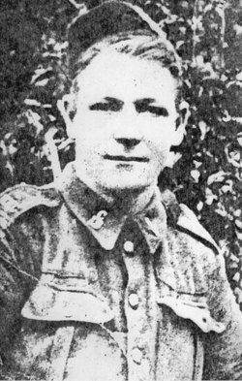
John Bernard Croke
(1892-1918)

- Born in Green Bay 1892.
- Was educated in Glace Bay Nova Scotia and was a miner.
- He joined the Canadian Corps.
- Croke was the first Newfoundlander to receive the Victoria Cross for his bravery in the Battle of Amiens.
- He was awarded the VC because even though he had been severely wounded in bombing a machine gun nest, he continued to fight.
- When his platoon encountered another enemy stronghold, he rushed forward, being wounded again and helped captured 3 machine guns and an entire German garrison.
- He later died of his wounds and is buried in France.

- 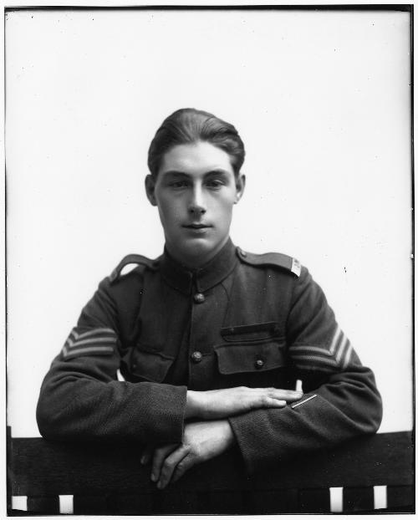
Tommy Ricketts
(1901-1967)

- Born in Middle Arm White Bay in 1901.
- He enlisted in 1916, having lied about his age.
- He was only 15.
- By 1917, he was fighting on The Front in France and suffered a bullet to the leg in Cambrai, France.
- He returned to battle in 1918.
- He was also awarded a Victoria Cross- the youngest recipient!!
- During the Battle of Courtrai , Ricketts and Lance Corporal Brazil volunteered to clear out a German battery but ran out of ammunition during the attempt.
- Disregarding his own safety, he doubled back under heavy machine gun and got more ammo.
- He ran back to the Lewis gun and forced the enemy to retreat.
- His platoon captured four field guns, four machine guns, and eight prisoners.
- Upon his return he studied pharmacy and opened a successful business on Water Street.
- He died February 1967.

