**Needs and Wants of the First Nations and Inuit**

**How did the First Nations take care of their needs and wants?**

- First Nations Peoples and the Inuit depended on the land for their survival.

-The economy of each Nation depended on the resources available in a region. For example in Baffin Island Inuit used snow, whale bones sod and stone for winter houses and in summer they used bones, hides and the hides of seal or seals or caribou

Trees do not grow where they were.

-However in Labrador, the Inuit used wood as trees grow in Labrador.

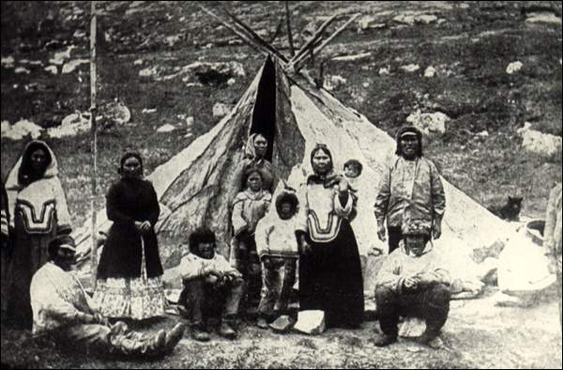

**Inuit in front of their skin tent (tupiq), Okak, Labrador, 1896 (heritage.nf.ca)**

**Production of Goods by the First Nations and Inuit**

**So how did the First Nations and Inuit make goods?**

* All goods that that the First Nations and Inuit needed or wanted were produced by hand.
* They used stone and bone tools to make what they needed.
* When they killed an animal, they used every part of the animal. For example, if they killed a caribou they used the hide for shelter and clothing, the meat for food and the bones for tools such as knives, needles and combs.
* Most aboriginals had a seasonal pattern of activity meaning that they did different activities in different seasons. In the spring they went to the coast or to rivers to fish. In the winter they moved inland to hunt caribou
* They often travelled together in large groups and everyone had a job to do. Men would do the hunting while women did the meal preparation and prepare the meat and hides

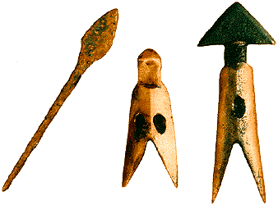 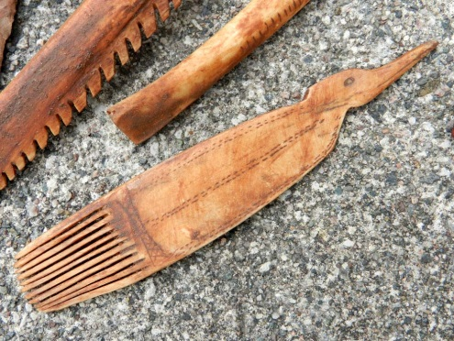

Tools for hunting Bone comb

**Distribution of Goods by the First Nations and Inuit**

**How did the First Nations and Inuit get goods?**

-everyone helped in production of tools, meals etc. so everyone shared equally the goods that were made.

-People helped one another in hard times.

- Being able to hunt over large areas was very important. In some regions, Nations would defend their lands from other nations.

-In other regions, nations shared the forest, rivers, resources (ex. Maliseet and

Mi‛kmaq) and some nations traded with one another. For example the Innu often traded with the Algonquin for corn.

- a very important idea of the First Nations and Inuit was that everyone owned the land. For one person to own land was like owning air – you can’t do it.

- they did **not** believe in private land ownership – the idea that one person has control over an area of land. Some tribes/families had the right to hunt in certain areas but they did not “own” that area.

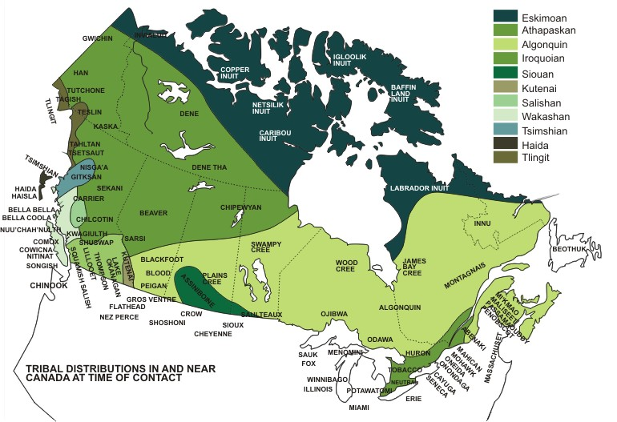

Different tribes in Canada prior to Contact with Europeans

**Needs and Wants of the European settlers**

**What did the Europeans Need/Want?**

**-**Beginning about 1500, Europeans began arriving in North America.

- Europeans left their homeland for three main reasons:

1. Europeans wanted to own more and so they were looking for land to take over.
2. Some Europeans felt that their culture, especially their religion, should be spread around the world
3. Europeans were also looking for economic opportunities (make money)

MC900185670[1] 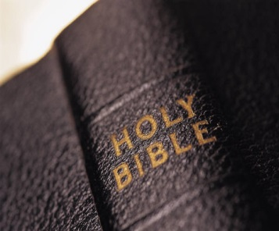 

**Land Religion Money**

* The Europeans believed in private land ownership. This was something very important to them.
* Many people in Europe couldn’t own land. Most land was owned by royalty or rich people (nobility).
* Most people had to rent land or work for a landowner to get a piece of land. A few lived in wealth while most lived in poverty.
* So, many European families came to North America hoping to be given or buy a piece of land of their own

**Production of Goods by the Europeans**

**So how did the Europeans produce goods?**

- Until the 1700s Europeans used basic tools to make things by hand.

- Many tools were metal that made work easier.

-Factories started in the 1700s.

- Even with factories, many people made everyday objects by hand in homes with the help of animals.

- Some goods were made by people who specialized in a product (cooper, baker, dressmaker, blacksmith)

- People in the country made more of their own goods than city folk.

- Ex. People in the country spun sheep‛s fleece into wool, men made their own barrels (coopers).

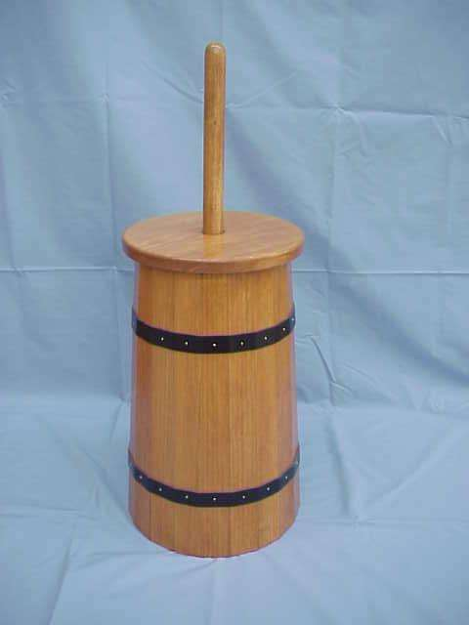 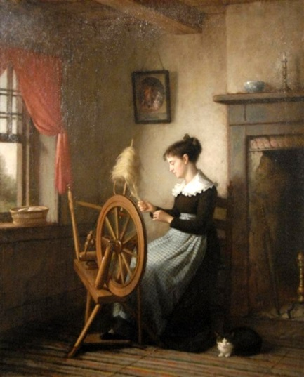

**Butter churn Spinning wheel**

**Distribution of Goods by the Europeans**

**So how did the Europeans get goods?**

* In Europe, the economic system was based on the idea that if you owned land or a resource you had the right to make as much profit as possible.
* The main goal was for people to work to benefit themselves and their family.
* The most common way for goods and services to be distributed was through markets.
* If you wanted something you paid for it with money!

* European settlers who came to North America had to begin by making do with what they had brought with them, could make for themselves, or could get by trading.
* Eventually they set up markets in their new homeland that were like those back home in Europe.

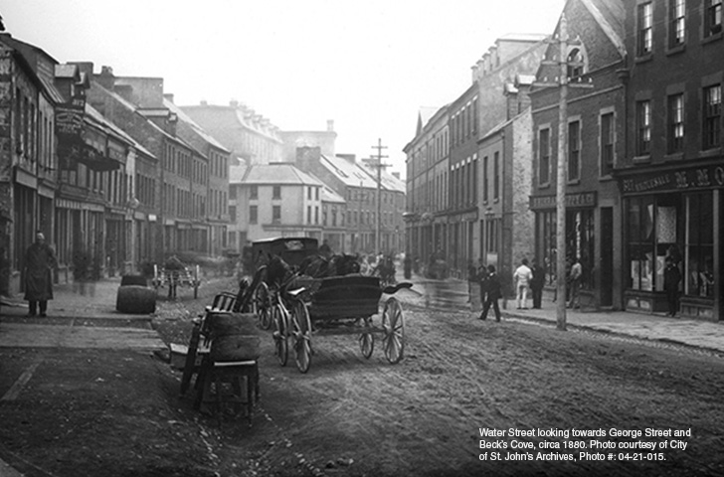

**Water Street, Downtown St. John’s ( 1880) location of many stores/markets**

**Chapter 2 : Worksheet #2 (Stations Activity)**

**Name: ________________________________________________**

**Station One: How did the First Nations take care of their needs and wants?**

1. After reading the information at Station One, explain the needs and wants of the First Nations and Inuit. Make sure to give examples.

________________________________________________________________________________________________________________________________________________________________________________________________________________________________________________________________________________________________________________________________________________________________________________________________________________________________________________________________________________________________________________________________________________________________________________________________________________________________________________________________________

1. Look at the map on page 26-27 and using the legend on page 26 list the main resources used by a) Beothuk, b) Labrador Inuit and c) the Innu

a) ____________________________________________

b) ____________________________________________

c)_____________________________________________

1. Sketch an Inuit tupiq/tupet in the space provided

**Station Two: How did the First Nations and Inuit make goods?**

1. How did the aboriginal people make their goods?

_______________________________________________________________________________________________________________________________________________________________________________________________________________________________________________________________________________________________________________________________________________________________________________________

1. What did they do to animal when they killed it?

_______________________________________________________________________________________________________________________________________________________________________________________________________________________________________________________________________________________________________________________________________________________________________________________

1. What does “seasonal pattern of activity” mean?

_______________________________________________________________________________________________________________________________________________________________________________________________________________________________________________________________________________________________________________________________________________________________________________________

**Station Three: How did the First Nations and Inuit distribute goods?**

1. Who helped in the production of goods?

_______________________________________________________________________________________________________________________________________________________________________________________________________________________________________________________________________________________________________________________________________________________________________________________

1. How important was access to land? Did any groups trade with one another?

_______________________________________________________________________________________________________________________________________________________________________________________________________________________________________________________________________________________________________________________________________________________________________________________

1. Circle True or False Aboriginals believed in private land ownership

**Station Four: Needs and Wants of the European settlers**

1. When did the Europeans start arriving in North America? __________________

11) Why did Europeans leave their homeland? (3 Reasons)

a)__________________________________________________________________________

b)__________________________________________________________________________

c)__________________________________________________________________________

12) Why did people from European think that land ownership was so important?

_____________________________________________________________________________________________________________________________________________________________________________________________________________________________________________________________________________________________________________________________________________________________________________________________________________________

**Station Five: European Production of Goods**

1. Until the 1700’s, how did people make goods? ________________________.
2. When did factories start? _______________________.
3. What were some specific jobs people worked at?

________________________________________________________________________

1. Sketch a picture of one of the artifacts shown on the information sheet

**Station Six: Distribution of Goods by the Europeans**

1. The economic system of Europe is based on what idea?

________________________________________________________________________________________________________________________________________________________________________________________________________________________________________________________________________________________________________________________

1. How were goods distributed? ______________________________________
2. When Europeans first moved here, what did they do for distributing goods?

_____________________________________________________________________________

_______________________________________________________________________________________________________________________________________________________________________________________________________________________________________