Grade 7 Socials Review sheet 2013
Chapter 3: Economic Security
Name: ___________________________________

- What is economic security? Why do we need it? (notes)

Economic security is having enough income ($) to take care of your needs and have a good standard of living. If you are economically secure, you will have enough money to take care of any emergencies that come up. This is important because being economically secure keeps you out of the poverty cycle.

- What does capitalism mean? (pg. 43/44)

Capitalism is an economic system where goods and services are provided by individuals and where people are free to become as rich as they are able.

- What is the difference between and need and a want? Give an example of each. (notes)

A need is something that you have to have in order to survive. An example of a need is shelter/food. A want is something that you would like to have, but you don’t need it to survive ex. PS4, certain brand of clothing.

- Draw a diagram showing how money moves through a capitalist society. Make sure to label your diagram. ( pg. 44)
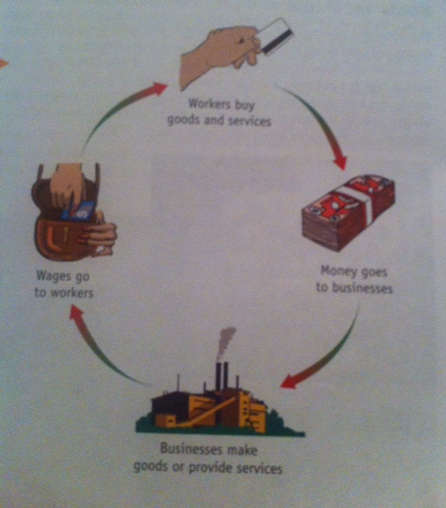

- Fill in the following chart showing three differences between capitalism and socialism. (pg. 45)

Capitalism | Socialism
Individual freedom is highly valued | Whats best for the group is more important than individual freedom.
Private individuals provide goods and services | The government provides goods and services
Competition is important to create wealth and improve society | Cooperation is important to create wealth and improve society

- What is the difference between capital and profit? (pg. 46)

Capital is the money that is put into a business to start it up and keep it running. Profit is the money that an owner makes after all expenses have been paid and any loans have been paid back.

- What are three types of businesses you can find in a Canadian economy? Give an example. (pg. 46)

- Small local businesses ex. Mowing lawns, clearing driveways (some people work on their own)

- Family run businesses ex. farmers, fishers, O’Briens music store_____

- Larger (corporate) businesses ex. sears, walmart, Tims, Target

- What is an entrepreneur? (pg. 47)

An entrepeneur is a person who gets an idea to start their own business ex. Chris Griffiths,

- In a cause and effect chain, what is the trigger? (pg. 49)

The trigger is the event that started the cause and effect chain in the first place. It’s the first cause.

- A fish plant closes down in a Newfoundland outport. Draw a cause and effect chain to represent what may happen in that community. (see pg. 49 for a sample)

See next page…………
Lack of fish
The trigger

Lack of $ on the community
People move away to find work
Fish plant closes
People lose their jobs

Place becomes a ghost town…and so on

- Draw three pigs to represent poverty, getting by and a chance to get ahead (pg. 50)

Income needed to meet basic needs
Poverty Getting by Chance to get ahead

- What is “standard of living”? (pg. 50)

Standard of living is the measure of how much buying power a family has. It is not always the best measure of poverty though.

- Describe one way how a person can get trapped in the poverty cycle. Draw a picture to show your example. (pg. 52)
If you do not have a car or other transportation, you may not be able to get to work or to an interview. As a result you may not get a job .If you don’t get a job, then you can’t save up to pay for transportation such as a car. As a result you still can’t get a job . And so the cycle continues
Diagram:
Poverty

No transportation
Can’t get to job interview

- What is personal capital? What does it include? (pg. 54)
Personal capital includes anything you have that can help you improve your economic situation.
Some examples of types of personal capital might include: Savings in the bank, Skills, Willingness to work hard and property

- What is the difference between a down-payment and a mortgage? (pg. 55)

The portion of a home that a family pays to start off is called a downpayment. A mortgage is money borrowed from the bank. After a down-payment is made then the rest has to be borrowed in order to purchase a house.

- How can people break the poverty cycle? (pg. 55)

People can break the poverty cycle in many ways. One way that a person can break the poverty cycle is to get training or further education to improve your job skills. The poverty cycle can also be broken when people work together to help each other.

- What does the program “Habitat for Humanity” do? Describe what the program uses as well as what homeowners have to do. ( pg. 56)

Habitat for Humanity is a volunteer organization that helps families get around the problem of needing a lot of capital to buy a house. It uses cash donations , volunteer workers and donated materials to build houses for people. They work together with the people in need so that these people can have their own home. The new homeowners have to contribute by doing 500 hours worth of work on the house and helping Habitat for Humanity in other ways.

For the test students need to study:

- This review sheet
- Their vocab sheet given at the start of the chapter
- Their chapter 3 notes/worksheets including this one
- Their textbook

The test is Nov. 21st.

