Grade 7 Socials

Chapter 3: Economic Security

Booklet Answer Key

- What is economic security?

Having enough money to take care of your needs (ex. food, shelter, clothing etc.) PLUS having enough money to take care of your wants (Ex. to save up money, take a vacation, etc.) or having enough should you need emergency funding

- Examples of needs: food, shelter, clothing

- Examples of wants: playstation, iPhone, iPad, TV etc.

- Fill-in-the-blank

- In a capitalist system, most people get the products they need by purchasing them through private companies.
- The main goal of these companies is to obtain a profit for the owners.
- Most people get what they need by buying things.
- Most people earn the money they need by working for a company.
- People who have the skills to run a business or get jobs with good wages will become the wealthiest society in general.

- Draw and label a diagram of how money moves through an economy
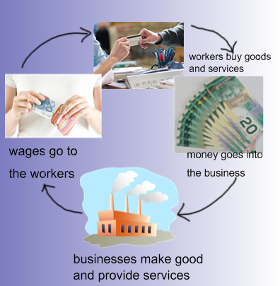

- Compare Capitalism to Socialism using the following chart:

Capitalism | Socialism
Individual freedom is most important | The group's interests are more important than individual freedom
The production of goods and services depends on individuals | The production of goods and services depends on the Government
The ability of people to meet their needs depends on their wealth | Each individual should receive what they need in order to survive
It is all about competition | Its all about cooperation

- Capitalism comes from the word capital.

- One way to define capital is the money and other things that have to be invested or put into a business venture to start it up and keep it going

- Profit istThis is the money the business owner makes after being repaid for the investment and paying other expenses.
- There are many types of businesses in our communities. Define each.

- Personal business: when someone starts their own small business.
- Family business: when family members work together in a family owned business
- Larger business: businesses that might be owned by big companies based in other parts of Canada or the world.

- How do businesses benefit each other?

When a new business starts up, it helps create wealth. Businesses start to benefit each other when workers get their pay cheques and they start spending money in other stores for their needs and wants.

- Define entrepreneur person who gets an idea to start their own business.
- Who is Chris Griffiths? He is an entrepreneur who started his own business that makes guitars. It was called Garrison Guitars.
- What was his new idea? His new ideas was to construct a new kind of acoustic guitar that was made out of fiberglass.
- How many employees were there in 2002? 57

Cause and Effect Chains

A cause and effect chain shows the connection between events. There are three parts: a trigger, a cause and an effect.

- Define cause: is what makes a change happen
- Define effect: is the change that happens
- Define trigger: what starts the cause and effect chain to start in the first place.
- Complete the following cause and effect chain: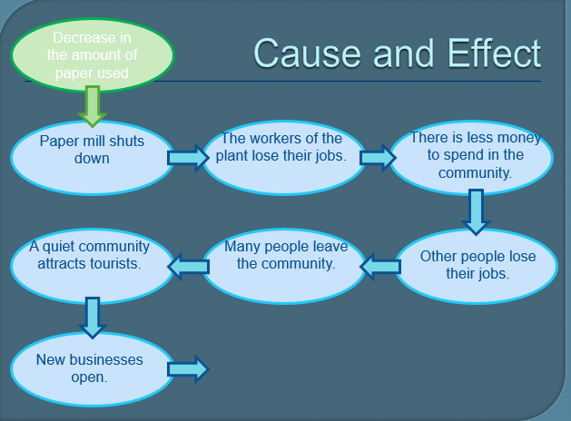
- Fill out the following chart:

Expenses for Basic Needs | Income | Result | Quality of Life
$100 | $90 | Poverty | Poor  Stressed
$100 | $100 | Getting By | Satisfactory  Can feel stress worry
$100 | $125 | A Chance to Get Ahead | Good

- Draw the poverty cycles on page 52.

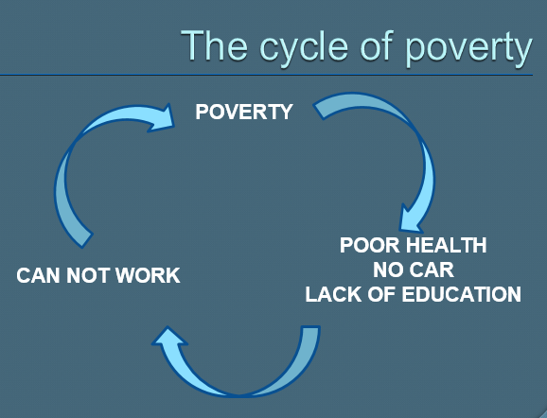

Building Personal Capital

- Personal Capital includes anything you have that can help you improve your economic situation.
- Some examples of types of personal capital might include:
Skills
Property
Willingness to work hard
Savings in the bank

- If you take advantage of a sale on soup (or something else), you will be able to save money by buying many cans on special instead of just one. This money can then be used to help you save even more money.

Owning a Home

- A family’s home is usually its biggest personal capital investment.
- The portion of a home that a family pays to start off is called a down payment
- A mortgage is the rest of the cost of the house that is borrowed from the bank and paid back over time.
- Each month, the family makes a payment that increases the amount of the house that it owns.

- Fill in the following diagram showing how a mortgage increases a family’s capital.

First Year 5 years 10 years 15 years 20 years
owning home owning home owning home owning home owning home

Breaking the Poverty Cycle

- People who are caught in the poverty cycle have little chance to increase their Personal Capital
- People can break the poverty cycle in many ways. One way that a person can break the poverty cycle is to get training or further education
- The poverty cycle can also be broken when people work together to help each other.

A Closer Look: Habitat for Humanity
.
- Who are Habitat for Humanity?

Habitat for Humanity is a volunteer organization that helps families get around the problem of needing a lot of capital to buy a house. It uses cash donations , volunteer workers and donated materials to build houses for people.

- What do they do to help people break out of the poverty cycle?
They work together with the people in need so that these people can have their own home. They help them have a chance to get ahead by giving them a low mortgage payment and also help them get personal capital by owning a house.

- What do the new homeowners have to contribute to the house or to Habitat for Humanity?

They contribute by doing 500 hours worth of work on the house and helping Habitat for Humanity in other ways.

The newspaper article (page 56)

- Ana Nan has a son who is 6 years of age when their home was built.
- Ana Nan earns about $ 25, 000 each year.
- The home that they built for her is valued at about $75,000
- Her mortgage on this new home is about $ 160 per month.
- Ms. Nan and her son are said to be good examples of a ‘Habitat family’ because they are hard-working and considerate
- Ms. Nan worked as a registered nurse in her home country of Romania.
- More than 5000 hours of work went into the home.
- There is one Habitat home completed somewhere in the world every 48 minutes.

