Three Angry Men – Reformers in BNA

Name: ___________________________________

Joseph Howe

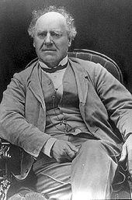­­­­­­­



_____________________________________________________________________________________________________________________________________________________________________________________________________________________________________________________________________________________________________________________________________________________________________________________________________________________________________________________________________________________________________________________________________________________________________________________________________________________________________________________________________________________________________________________________________________________________________________________________



Louis Joseph Papineau

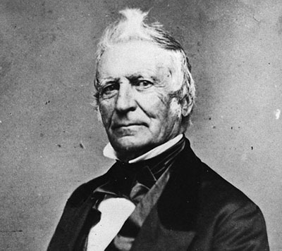



____________________________________________________________________________________________________________________________________________________________________________________________________________________________________________________________________________________________________________________________________________________________________________________________________________________________________________________________________________________________________________________________________________________________________________________________________________________________________________________________________________________________________________________________________________________________________________________________



William Lyon Mackenzie

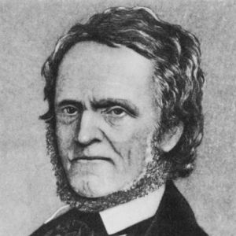

* He was a reformer from Upper Canada.
* He grew up in a poor family in Scotland.
* He started a newspaper in Upper Canada that criticized the elite.
* He had a bad temper and would take off his wig and shake it at people.
* He lead a rebellion in Upper Canada. His troops were defeated by the militia but eventually Canada did get responsible government.