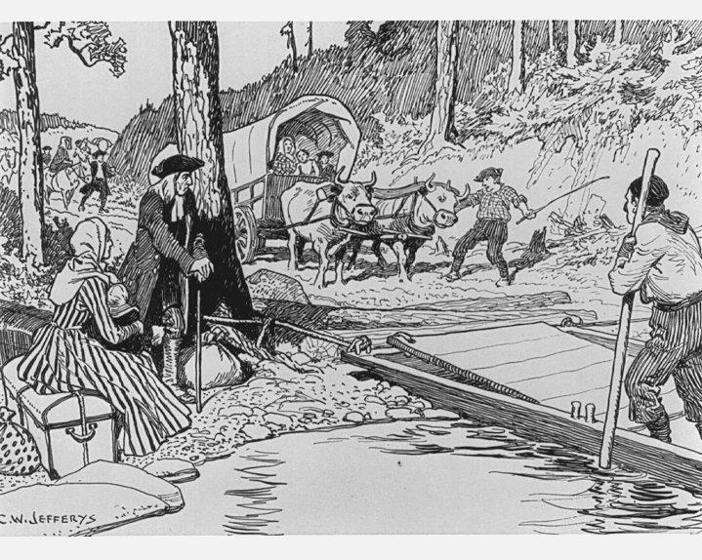

Social Studies Grade 7
2016

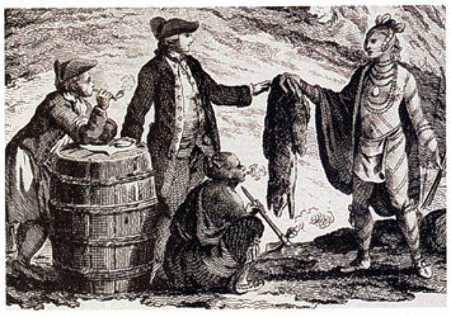

The People of
British North America

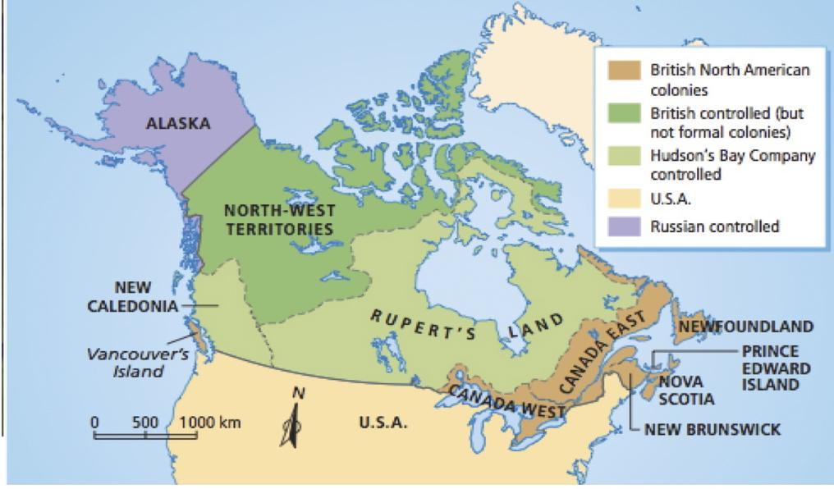
Name and Homeroom:

Miss Ball’s Answer Key
(worksheets adapted from original and other teachers shared resources)

Section One: The British and Irish

Read it! : Read pages 82 and 83 and then fill in the blanks

The Peoples of British North America (p. 82)
- An immigrant is a person who comes to live in a country that is not his or her original home. (see the box at the side of the page)

- In the early 1700s and 1800s, most of the immigrants came from Europe

The British and Irish (p. 82)
By the mid-1800s, approximately __two thirds____ of the European population of BNA was British or Irish.

A class of people who have more political, economic and social power are called the ___elite____________.

The __loyalists________________ came to Canada after the American Revolution.

In Newfoundland, the British __merchants______________ also formed an elite.

The elite in all the colonies had:
most say in _government____
owned the _largest businesses______
set the social _standards_______

The elite weren’t interested in sharing their _____________power_____ with others.

The British and Irish (p.83)

Between 1815 and 1850, about 800 000__ immigrants came to BNA from England, Scotland and Ireland.

They came to BNA hoping for a _better life______

Many of the English were prejudice_______ against the Irish.

There were problems between the people of _Great Britain__ and in __Ireland________________

The Irish tended to be __Catholic________________ while the English tended to be __Protestant________________ (religions).

Define It! Write down the definitions for: (look in the box on the side of the page)

Prejudice: is a dislike or distrust of someone or group based on biased ideas or information

Discrimination: is an unfair treatment based upon prejudice

Section Two: The French

Read it! Read page 84 and fill in the blanks in the textbox
The French (p.84-85)

The two main groups were in _Canada East_________________ and the _Acadians__ in Atlantic Canada.
In Newfoundland, they lived along the _French Shore_______________________
When Great Britain took over BNA, they gave the French the rights to keep:
language customs
laws Roman Catholic faith
As more British and Irish moved into Canada East, the French feared they would become and minority and lose their rights.
Define: Habitants farmers living in rural areas

Investigate It! Read page 85 and find out the who, what, when, where and why of the Grand Derangement

Who?? The Acadians and the British were involved

What?? Between 8000 to 10000 Acadians were forced to leave their homes in the Grand Derangement/ Great Expulsion of 1755. After many years of war, Britain had gained control of the land called Acadia in the Treaty of Utrecht and the British didn’t trust them. Their homes were burned down, some were imprisoned, some killed, some were moved to other colonies, some hid in the woods and some marched to places as faraway as Louisiana. 50% of those exiled died.

Where??
Acadia included the areas of PEI , Nova Scotia, New Brunswick (later became provinces) and they moved to southern colonies, Louisiana, Newfoundland, Canada East and even France.

When?? This happened in August of 1755
Why?? The British made the Acadians leave because they didn’t trust them to stay loyal to Britain.
Between 8000 to 10000 Acadians were forced to leave their homes in the Grand Derangement/ Great Expulsion of 1755.

Activity: Sketch it!
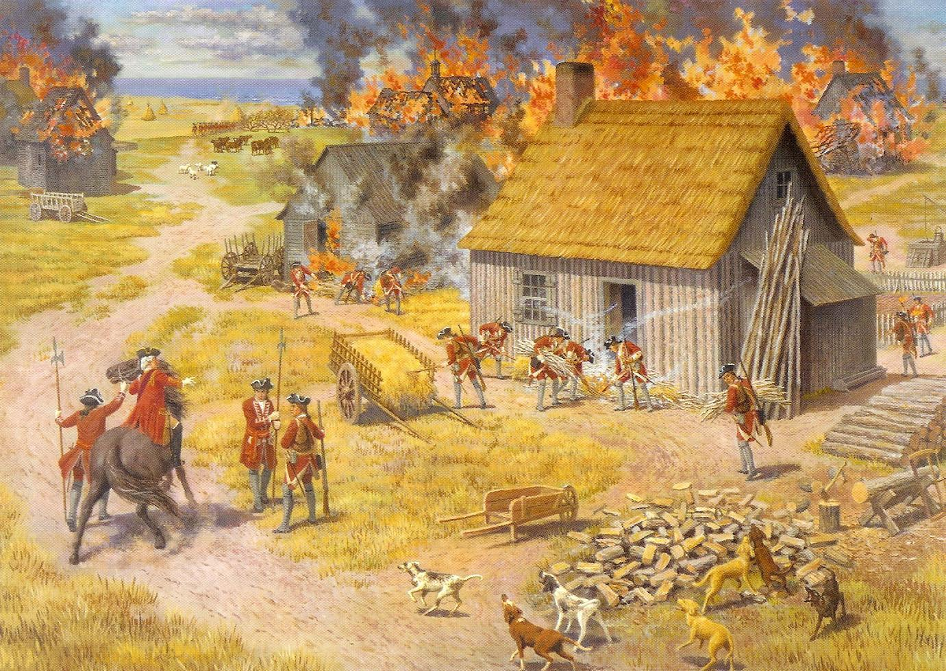
In the space below, draw a picture of what you think it might have looked like when the British came in to burn down their homes or as the Acadians were leaving their homes to find a new place to live

Activity! There are Three Sides to Every Story!

In this activity you will be placed into groups and will be assigned to be either British or Acadian. Using materials given to you by the teacher, you will find out how your “side” felt about the Grand Derangement and each group will present their views to the class. You will be provided with a chart paper and a marker. You will all contribute to what points you should write down. A recorder and reader should also be designated. We did this as a group activity in class. Students were grouped as either Acadians or British. They had to write down jot notes about their sides perspective and background information. Each group then presented their information.

Section Three: The Aboriginal Peoples

Define it! Read page 86 and 87 and find the following definitions

Racism: is a prejudice based on a person`s heritage or skin colour.
Resistance (to disease): this is when a person`s body is immune or able to fight off a disease. Many aboriginals did NOT have resistance.
Tuberculosis: this is a lung disease
Wampum: is a piece of material made from sinew and beads and it was used to communicate messages.

Fill It! Read pages 86 and 87 and fill in the blank
Aboriginal Peoples (p. 86-87)
The arrival of the Loyalists, British and Irish in the Maritimes created a demand for land
In Nova Scotia, PEI and New Brunswick, the First Nations people were left with only small areas of poor quality land.
The population of First Nations and Inuit dropped to about 102 000 in 1871.
The drop in population was mostly due to disease
By the mid-1800s, the largest Métis community was in Red River Settlement
The Red River Settlement was in the region controlled by Hudson`s Bay Company
Most Métis were involved in the fur trade in some way
They transported goods by canoe , wagon, or foot.
Why were Métis carts designed so their wheels could be taken off? So they could float the wagons across the Rivers.

Design it! Design your own wampum in the box provided. What message would it give the Europeans?
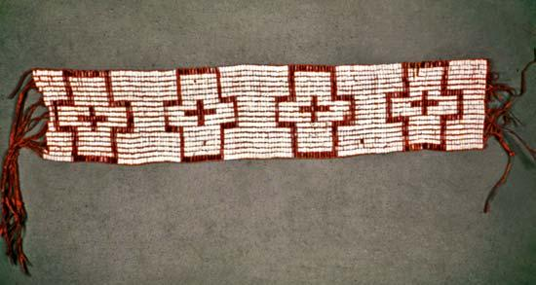

Section Four: The Black Colonists

Fill it! Read pages 88 and 89 and fill in the blanks!
Black Colonists (p.88-89)
Slavery was legal in BNA until 1834
Some Black people came from Jamaica , but most came from the United States
Approximately 3 000 Black Loyalists came to BNA and settled in Nova Scotia and New Brunswick.
They set up strong communities to provide: medical care , places of worship, and education_ for their people.
Black people came to BNA between 1840 and 1860 to escape to escape slavery in the US.
As white communities grew larger, Black colonists were forced to move farther from important resources such as water supplies and roads.
What job is the Black Loyalist doing in the image on page 88? logging

Define It! Give Definitions of these terms:
Title a legal record that the land is theirs
Slavery: when a person is “owned’” or is property of another person and must do what their owner says. For the black colonists were bought and sold by whites and had to do work for them.

Journal it! Which group do you feel suffered the greatest hardship and why? Or did they all face hardship but in different ways. Write your thoughts and feelings in the box below. Make sure to support your answer using information from the text and use a topic and concluding sentence.

________________________________________________________________________________________________________________________________________________________________________________________________________________________________________________________________________________________________________________________________________
________________________________________________________________________________________________________________________________________________________________________________________________________________________________________________________________________________________________________________________________________
________________________________________________________________________________________________________________________________________________________________________________________________________________________________________________________________________________________________________________________________________
________________________________________________________________________________________________________________________________________________________________________________________________________________________________________________________________________________________________________________________________________

Booklet Check:
Is every question completed?
Is your name and homeroom on the front of the booklet?
Are you with happy about how you worked on this booklet?
Give yourself a pat on the back. You are now finished your booklet ☺

