Grade 8 Social Studies
Chapter 5 Booklet
Lifestyles in the 19th century
Name and homeroom:________________

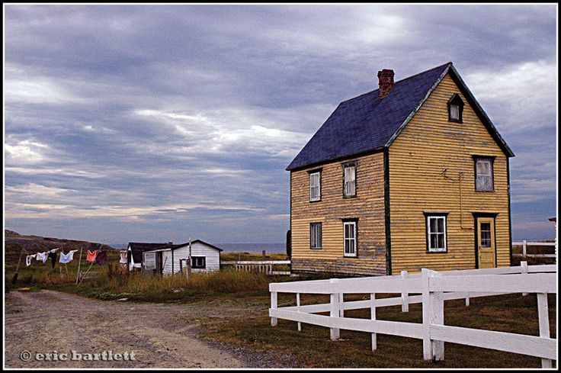

Grade out of 34 for completion: /34

Grade out of 10 for journal (#15): /10

Grade out of ____ for selected questions: /

Total grade:

Complete the following handout as each section is completed in the Voyage to Discovery Text

Section: Chapter Introduction (pages 96-97)

- a. What is lifestyle?

__________________________________________________

b. What are the five aspect of lifestyle?

_______________________
_______________________
_______________________
_______________________
_______________________

- Examine the painting on page 97 of the text. Complete the following table.

Title of painting

Setting

Who are the people/

What are they doing?

What aspect of lifestyle is this?

Section : Christmas in Newfoundland (page 104-106)

- Using information from page 104 and 106 and from your own personal experience, complete the following chart

Activity | Then | Now
Type of gifts given

Family Christmas traditions

Mummering

Foods eaten

- Tell about one tradition that you and your family or friends have a Christmas:

__________________________________________________________________________________________________________________________________________________________________________________________________________________________________________________________________________________________________________________________________________

Section: Family Life: Housing (page 98-99)

4 a) Draw a sketch of the 3 housing types you have read about and write a brief description

Type of House | Drawing | Description

4 b) How were people’s houses related to the way people made a living (their jobs)?
_______________________________________________________________________________________________________________________________________________________________________________________________________________________________________________________________________________________________________________________________________________________________________________________________________________
Section: Family Life: Food (page 100-101

- Describe at least four ways that people would meet their food needs in the 19th century.

- ____________________________________________________________________________________________________________________________________________________________
- ____________________________________________________________________________________________________________________________________________________________
- ____________________________________________________________________________________________________________________________________________________________
- ____________________________________________________________________________________________________________________________________________________________

- a. Give some examples of staple foods:

______________________________________________________________________________________________________________

b. Using your knowledge of foods available in the 19th century complete a three day menu. Be specific (ex. Don’t say “vegetables” –what specific vegetables??).

Day | Dinner | Supper
One
Two
Three

Section: Entertainment/Recreation (pages 102-103)

- Describe each of the following social activities in the 19th Century.

Activity | Description
Storytelling

Kitchen parties

Card games

Guy Fawke’s Night

Copying Pans

- What skill did the activity of copying pans prepare young people for? How did it prepare them? (Picture on page 103)

___________________________________________________________________________________________________________________________________________________________________________________________________________________________________________________________________________________

Section: Games and Sports (pages 108-109)
- In the chart below compare games played today with games played in the 19th Century
 | 19th Century | Today
Examples of games played (NOT sports)

Mainly played indoors or outdoors?
Mainly played by a group or individual?
What skills are required to play these games?

- From the timeline on page 107, list 10 sports that were played in the 19th Century.

- ____________ 6. ____________
- ____________ 7. ____________
- ____________ 8.____________
- ____________ 9.____________
- ____________ 10. ____________

Section: Churches in the Community (pages 110-111)
- What three aspects of life were the church involved in:

_______________, ______________ and _______________.

- Describe four ways that churches were involved in the community :
____________________________________________________________________________________________________________________________________________________________________________________________________________________________________________________________________________________________________________________________________________________________________________

- Who were the SPG and the Newfoundland School Society and what was their important to education in Newfoundland?
____________________________________________________________________________________________________________________________________________________________________________________________________________________________________________________________________________________________________________________________________________________________________________

Section: Healthcare in the 19th Century (pages 112-114)

- Write a brief biography of Sir Wilfred Grenfell.

____________________________________________________________________________________________________________________________________________________________________________________________________________________________________________________________________________________________________________________________________________________________________________________________________________________________________________________________________________________________________________________________________________________________________________________________________________________________________________________________________________________
_______________________________________________________

- Journal: To be answered in journaling exercise: Healthcare in the province today is much better than it was in the 1800s. Do you agree or disagree with this statement and provide supports for your answer.

Section: Communication and Transportation (pages 115-117)

16. Describe each of the following innovations in communication in the 19th C

Innovation | Description
Transatlantic Cable

Telegraph

Marconi’s Wireless

Coastal Steamship

Mail service

Railway

- From page 117, list 5 ways that people travelled in the 19th C?

- ____________________________________________________
- ____________________________________________________
- ____________________________________________________
- ____________________________________________________
- ____________________________________________________

