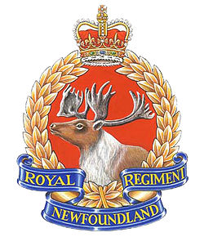
Beaumont Hamel Fact Sheet
Grade 8 Socials
Name and Homeroom: ___________________________________

Use pages 131-132 and in-class discussion to complete the following facts about Beaumont Hamel.

- Date of Beaumont Hamel: ________________________

- Country the Battle was fought in: ___________________________

- Name of the larger battle Beaumont Hamel was a part of: ______________________

- Newfoundland military group in the Battle: _______________________________

- Time of day they were they ordered out of their trenches: _____________________________

- How long the Battle lasted: _________________

- Define No Man’s Land : __________________________________________________________

_____________________________________________________________________________.

- Weapons were the Newfoundland soldiers were using: ______________________________

- Weapons the German’s were using: __________________________________

- Number of soldiers who entered the battle: _________________________

- Number who died: ______________

- Number who were missing: ____________

- Number who were wounded: ______________

- Number who answered roll call: __________________

- Three reasons why the Battle of Beaumont Hamel went wrong for the Newfoundland Regiment:

- ________________________________________________________________________________________________________________________________________________________________________________________________________________________________________________________________________________________________________________________
- _______________________________________________________________________________________________________________________________________________________________________________________________________________________________________________________________________________________________________________________
- _______________________________________________________________________________________________________________________________________________________________________________________________________________________________________________________________________________________________________________________

- Why is this Battle so important in our provinces history?

- ____________________________________________________________________________________________________________________________________________________________________________________________________________________________________________________________________________________________________________
- ____________________________________________________________________________________________________________________________________________________________________________________________________________________________________________________________________________________________________________
- ____________________________________________________________________________________________________________________________________________________________________________________________________________________________________________________________________________________________________________

- When was the first Memorial Day held here in Newfoundland? _______________________

- When was the Beaumont Hamel Memorial Park opened in France? _______________________

